NAME: S.PRATIBA
DATE:14.10.25 ROLL NO.:241901080

EXERCISE 16
TO CAPTURE, SAVE AND ANALYZE NETWORK TRAFFIC ON TCP/UDP/IP/HTTP/ARP/DHCP/ICMP/DNS USING WIRESHARK TOOL
AIM:
To capture, save, and analyse network traffic using Wireshark to understand protocol packet structures and develop competency in network analysis, troubleshooting, and security assessment.
ALGORITHM:
- Launch Wireshark - Open the application and verify the network interfaces available
- Select Network Interface - Choose active interface (Ethernet/Wi-Fi) and enable promiscuous mode
- Start Packet Capture - Click the Start button to begin capturing packets
- Generate Network Traffic - Open browser, ping hosts, browse websites to create TCP/UDP/ICMP/DNS traffic
- Stop Capture - Click the Stop button after collecting sufficient packets (50-200 packets typical)
- Apply Protocol Filters - Filter traffic using:
  - tcp for TCP packets
  - udp for UDP packets
  - icmp for ICMP ping traffic
  - dns for DNS queries
  - arp for ARP requests/replies
  - dhcp for DHCP messages
  - http for HTTP traffic
- Analyze Individual Packets - Select packet, examine headers (Ethernet, IP, TCP/UDP), view payload data
- Examine Protocol Layers - Review encapsulation from Layer 2 (Ethernet) → Layer 3 (IP) → Layer 4 (TCP/UDP) → Layer 7 (Application)
- Save Capture File - File → Save As, choose format (pcapng or pcap), save with descriptive filename
- Generate Statistics - Use Statistics menu to view protocol hierarchy, conversations, and endpoints
- Document Findings - Record observations about protocol behavior, connections, and traffic patterns
- Create Analysis Report - Compile results with conclusions about network communication

OUTPUT:
- CAPTURE THE PACKET
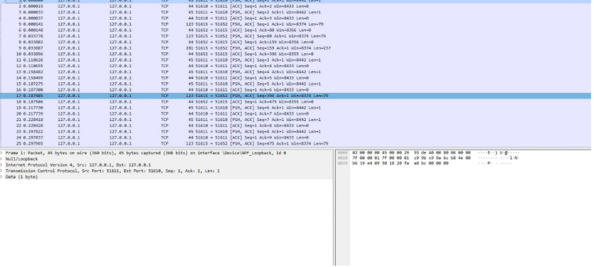
- CAPTURE THE TCP/UDP PACKETS
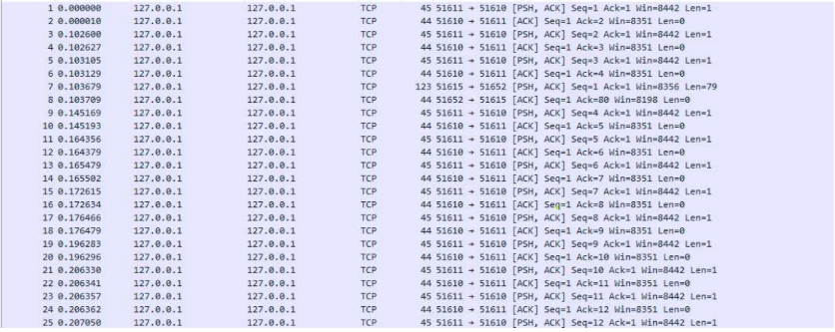
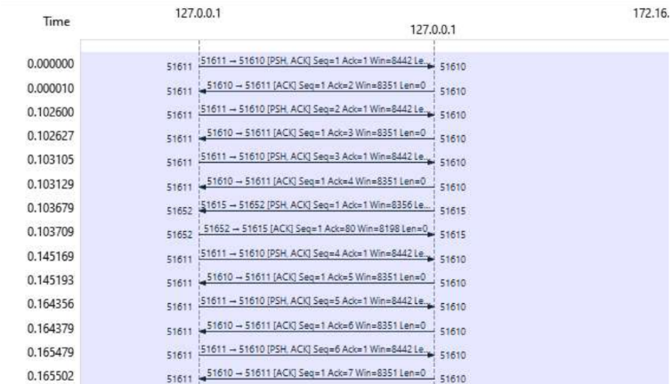

- CAPTURE ARP PACKET
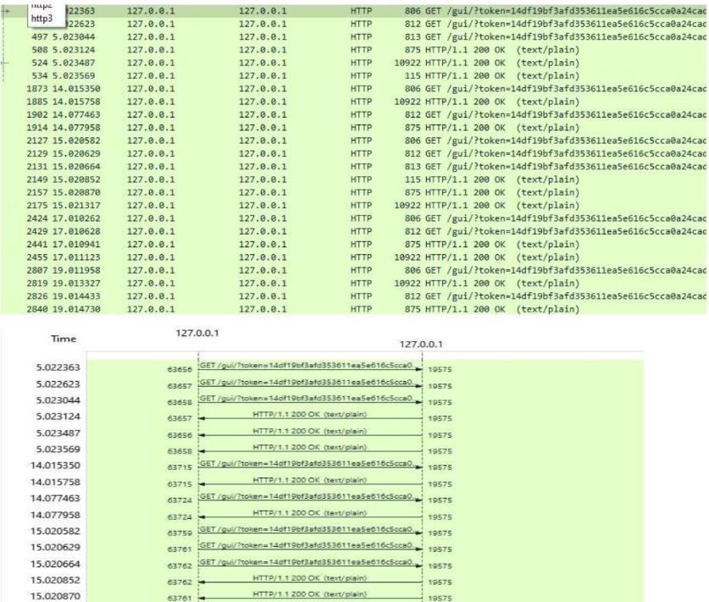

- CAPTURE IP/ICMP PACKETS
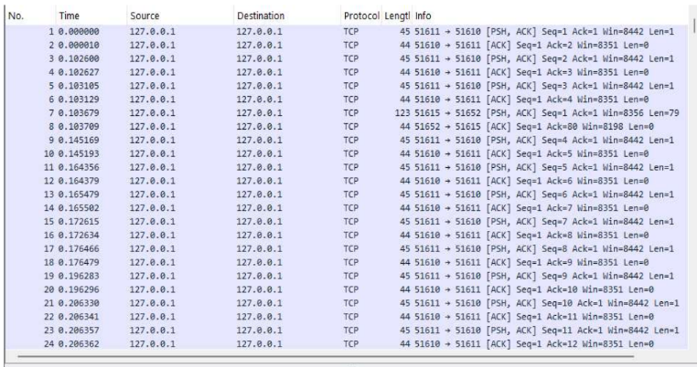

RESULT:
Wireshark captures and displays packets for all major protocols, enabling analysis of handshake sequences, address mappings, and network statistics across TCP, UDP, ICMP, ARP, DHCP, DNS, and HTTP.

